Patent draft

On

**E-commerce for Artisans**

Submitted as a part of the course curriculum for

**Bachelor of Technology**

in

**Computer Science**



**Submitted by**

Prakhar Sharma(prakhar.2125cs1004@kiet.edu)

Nikhil Garg(Nikhil.2125cs1012@kiet.edu)

Navneet Saini(navneet.2125cs1140@kiet.edu)

Diwakar Mittal(diwakar.2125cs1007@kiet.edu)

**Under the Supervision of**

Dr. Harsh Khatter

Associate Professor

**KIET Group of Institutions, Ghaziabad**

**Department of Computer Science**

**Dr. A.P.J. Abdul Kalam Technical University**

**2023-2024**

**TABLE OF CONTENTS**

|  |  |
| --- | --- |
|  | Page No. |
| TITLE PAGE .................................................................................................................... | 1 |
| ACKNOWLEDGEMENT.................................................................................................. | 3 |
| PROBLEM STATEMENT................................................................................................ | 4 |
| ABSTRACT....................................................................................................................... | 5 |
| BACKGROUND................................................................................................................ | 6 |
|  |  |
| CHAPTER 1 FEATURES | 7-8 |
| 1.1.          Field Of Innovation…................................................................... | 7 |
| 1.2.          Objective...…………………………………...………………… | 8 |
|  |
| CHAPTER 2 MODELLING | 9-11 |
| 2.1 FlowChart..................................................................................... | 9 |
| 2.2 E-R Diagram................................................................................. | 11 |
| CHAPTER 3 TECHNOLOGY IMPLEMENTED ………………..………………. | 12 |
| CHAPTER 4 END USER.......................................................................................... | 14 |
| CHAPTER 5 CONCLUSION …....................................................................................... | 15 |
| REFERENCES….............................................................................................................. | 16 |
|  |  |
|  |  |

**ACKNOWLEDGEMENT**

It gives us a great sense of pleasure to present the synopsis of the B.Tech Project undertaken during B.Tech. Third Year. We owe a special debt of gratitude to Dr. Harsh Khatter, Associate Professor, Department of Computer Science, KIET Group of Institutions, Delhi- NCR, Ghaziabad, for his constant support and guidance throughout our work. His sincerity, thoroughness, and perseverance have been a constant source of inspiration for us. It is only his/her cognizant efforts that our endeavours have seen the light of the day.

We also take the opportunity to acknowledge the contribution of Dr. Ajay Kumar Shrivastava, Head of the Department of Computer Science, KIET Group of Institutions, Delhi- NCR, Ghaziabad, for his full support and assistance during the development of the project. We also do not like to miss the opportunity to acknowledge the contribution of all the faculty members of the department for their kind assistance and cooperation during the development of our project.

Last but not the least, we acknowledge our friends for their contribution to the completion of the project.

Signature: Dr. Harsh Khatter

Student’s Name: Signature:

Roll No:

**PROBLEM STATEMENT**

The problem statement for the "E-Commerce for Artisans" project could be articulated as follows:

"In the contemporary marketplace, traditional artisans often face significant challenges in reaching a global audience and monetizing their craft. The absence of an effective online platform tailored to their unique needs hinders their potential for growth and economic empowerment. Local artisans encounter barriers related to limited market exposure, complex transaction processes, and insufficient technological infrastructure. Additionally, the lack of a centralized hub for traditional craftsmanship often results in the underappreciation and underrepresentation of these skilled artisans in the digital sphere.

This project aims to address these challenges by developing a specialized e-commerce platform that caters specifically to artisans. The goal is to create a user-friendly, secure, and culturally sensitive online marketplace that not only enables artisans to showcase and sell their creations but also fosters a sense of community and appreciation for traditional craftsmanship. By doing so, the project seeks to empower artisans economically, preserve cultural heritage, and provide them with the tools needed to thrive in the evolving digital economy."

**Advantages**

• **Increased Market Reach**: Artisans can sell their products beyond their local markets, reaching a global audience, which significantly expands their customer base.

• **Cost-Effective Sales Channel**: An online platform reduces the need for physical stores or market stalls, lowering overhead costs associated with traditional retail.

• **24/7 Availability**: Unlike physical stores, an e-commerce platform is open around the clock, allowing customers to shop at any time, which can lead to increased sales.

• **Direct Customer Engagement**: The platform can facilitate direct interaction between artisans and customers, enabling personalized service and fostering customer loyalty.

• **Customization and Flexibility**: Artisans can showcase their unique products with detailed descriptions, high-quality images, and even stories about their craft, creating a personalized shopping experience.

• **Data Analytics**: The platform can provide valuable insights into customer behavior, preferences, and trends, enabling artisans to tailor their products and marketing strategies accordingly.

• **Diversified Income Streams**: By selling online, artisans can explore additional income streams such as offering custom orders, online workshops, or subscription services.

• **Support for Niche Products**: E-commerce platforms can help artisans find and connect with niche markets that appreciate and seek out handmade, unique, or culturally significant products.

• **Empowerment and Independence**: Artisans gain more control over their business, including pricing, marketing, and branding, which can lead to greater financial independence.

**ABSTRACT**

The "E-Commerce Empowerment for Artisans" project seeks to revolutionize the traditional marketplace by providing a robust online platform tailored specifically for artisans. In a rapidly evolving digital landscape, this initiative aims to bridge the gap between skilled artisans and a global audience of art enthusiasts, fostering a vibrant online marketplace that celebrates craftsmanship.

Our platform offers artisans a user-friendly interface to showcase their unique creations, ranging from handcrafted goods to artistic masterpieces. Through this digital storefront, artisans gain unprecedented access to a diverse consumer base, enabling them to expand their reach beyond local markets. The project focuses on empowering artisans with the tools needed to manage their online presence, process transactions securely, and build lasting connections with customers.

Furthermore, the initiative emphasizes the preservation of cultural heritage and the promotion of sustainable practices. By integrating e-commerce technology with an appreciation for traditional craftsmanship, the project aims to uplift artisans economically while fostering a sense of community among users.

In conclusion, the "E-Commerce Empowerment for Artisans" project envisions a dynamic online marketplace where artisans can thrive, connecting their craftsmanship with a global audience and ensuring the preservation of cultural diversity in the digital era.

**Background**

The primary reason for creating an e-commerce website for artisans is to empower skilled craftsmen by providing them with a global platform to showcase and sell their unique, handcrafted products. Artisans often face challenges in reaching a broader audience due to limited access to traditional retail channels and marketplaces. By establishing an online presence, we can bridge this gap, enabling artisans to connect directly with customers who appreciate and value their craftsmanship.

This platform not only supports the livelihoods of artisans but also preserves and promotes cultural heritage by bringing traditional and contemporary crafts to the forefront. In a world increasingly dominated by mass-produced goods, offering a curated selection of authentic, handmade products appeals to conscious consumers seeking sustainability, quality, and originality.

Furthermore, the e-commerce site will highlight the stories and techniques behind each product, fostering a deeper connection between artisans and customers. By leveraging technology, we can enhance visibility, offer personalized shopping experiences and ensure secure transactions, creating a seamless and engaging experience for both artisans and buyers. Ultimately, this initiative aims to create a sustainable ecosystem that celebrates creativity, supports local economies, and offers consumers access to unique, high-quality artisan products from around the world.

**Field Of Innovation**

1. **Transparent Supply Chain**: Offer detailed information about the sourcing of materials, the artisans' backgrounds, and the production process to highlight the ethical and sustainable aspects of the products.
2. **Artisan Profiles**: Create dedicated pages for each artisan, showcasing their story, techniques, and the cultural significance of their work.
3. **Interactive Storytelling**: Use interactive media (videos, podcasts, virtual workshops) to connect customers with the artisans and the creative process behind the products.
4. **Live Selling Events**: Host live streaming events where artisans showcase their products, interact with customers, and offer exclusive deals.
5. **Community Building:** Foster a community around the platform where artisans and customers can interact, share stories, and provide feedback.
6. **Donation Integration:** Allow customers to donate a portion of their purchase to a cause related to the artisan community (e.g., education, healthcare).

**Objectives**

**1) Promote Artisan Craftsmanship**: Highlight and preserve traditional and contemporary artisan crafts by providing a platform where artisans can showcase and sell their handmade products.

**2) Expand Market Reach**: Enable artisans to reach a global audience, increasing their visibility and sales opportunities beyond local markets.

**3) Enhance Customer Experience**: Offer a personalized and immersive shopping experience, where customers can discover unique, high-quality products and learn about the artisans' stories and techniques.

**4) Support Sustainable and Ethical Practices**: Promote and ensure transparency in sourcing, production, and the supply chain, emphasizing sustainability and fair trade practices.

**5) Foster a Creative Community**: Build a community that connects artisans with customers and other artisans, fostering collaboration, cultural exchange, and appreciation of craftsmanship.

**6) Provide Secure and Convenient Transactions**: Ensure a seamless, secure, and user-friendly purchasing experience, with flexible payment options and reliable customer service.

**FLOWCHART**

**Start**

**↓**

**[Define Project Scope]**

**↓**

**[Market Research]**

**↓**

**[Identify Target Artisans]**

**↓**

**[Design User Interface]**

**↓**

**[Develop E-Commerce Platform]**

**↓**

**[Artisan Registration]**

**↓**

**[Product Listing]**

**↓**

**[Secure Payment Integration]**

**↓**

**[Order Processing]**

**↓**

**[Shipping & Delivery]**

**↓**

**[Customer Registration]**

**↓**

**[Product Browsing]**

**↓**

**[Add to Cart]**

**↓**

**[Secure Checkout]**

**↓**

**[Payment Confirmation]**

**↓**

**[Order Confirmation]**

**↓**

**[Email/SMS Notifications]**

**↓**

**[Feedback Collection]**

**↓**

**[Artisan Rating]**

**↓**

**[Analytics & Reporting]**

**↓**

**End**

**E-R Diagram**

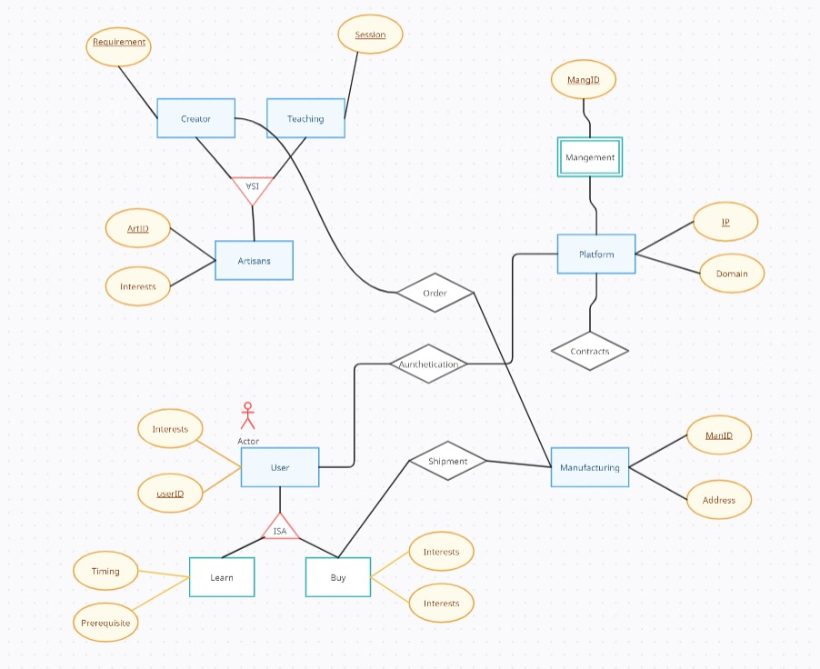

**TECHNOLOGY IMPLEMENTED**

Implementing an e-commerce platform for artisans involves a combination of technologies to create a robust and user-friendly system. Here's a list of technologies commonly used for such projects:

1. **Website Development:**

- **HTML, CSS, JavaScript:** Basic web development technologies for creating the front-end interface.

- **React, Angular, or Vue.js:** Popular front-end frameworks for building dynamic and responsive user interfaces.

- **Node.js, Django, Ruby on Rails:** Server-side frameworks for handling the back-end logic.

2. **Database Management:**

- **MySQL, PostgreSQL, MongoDB:** Databases to store and manage product information, user data, and transaction records.

3. **E-commerce Platforms:**

- **Shopify, WooCommerce, Magento:** Existing e-commerce platforms that can be customized for artisanal products.

- **Custom-built platforms:** Tailored solutions designed from scratch to meet specific requirements.

4. **Payment Integration:**

- **Stripe, PayPal, Square:** Payment gateways for secure online transactions.

- **SSL/TLS Certificates:** To ensure secure data transmission.

5. **Security Measures:**

- **HTTPS:** Secure communication protocol to protect user data.

- **Firewalls, DDoS Protection:** Safeguards against cyber threats.

6. **Cloud Services:**

- **AWS, Azure, Google Cloud:** Cloud platforms for hosting, scalability, and data storage.

7. **Analytics and Tracking:**

- **Google Analytics, Mixpanel:** Tools for monitoring user behavior, tracking sales, and obtaining insights.

8. **Search Engine Optimization (SEO):**

- **SEO Best Practices:** Implementing techniques to improve search engine visibility.

9. **Communication and Customer Service:**

- **Chatbots, Live Chat Services:** Automated or real-time communication for customer support.

10. **Social Media Integration:**

- **APIs for Facebook, Instagram, etc.:** Integrating social media for marketing and product promotion.

11. **Mobile and Email Marketing:**

- **Mailchimp, SendGrid:** Tools for email marketing campaigns.

12. **Inventory and Order Management:**

- **ERP Systems:** Enterprise Resource Planning for managing inventory, orders, and logistics.

**End Users**

**Individual Artisans**: Craftspeople and artists looking to sell their handmade products online, reach a broader audience, and establish a digital presence.

**Small Artisan Cooperatives**: Groups or collectives of artisans who wish to sell their products under a shared brand or market umbrella, enhancing their market visibility.

**Ethical and Sustainable Shoppers**: Consumers who prioritize purchasing products that are ethically sourced, handmade, and environmentally sustainable.

**Cultural Enthusiasts**: Individuals interested in collecting or gifting culturally significant and unique artisan products that reflect traditional craftsmanship.

**Interior Designers and Decorators**: Professionals seeking unique, handcrafted items to enhance their design projects with personalized and artisanal elements.

**Gift Shoppers**: Customers looking for unique, personalized, and meaningful gifts, especially for special occasions like weddings, anniversaries, or holidays.

**Boutique Retailers**: Small boutique stores that want to source unique, handmade products from artisans around the world to sell in their physical or online stores.

**Art Collectors**: Individuals interested in acquiring handmade art pieces, limited edition crafts, or custom-made items directly from artisans.

**Cultural Institutions and Museums**: Organizations that may purchase or commission artisan products for exhibitions, educational programs, or museum gift shops.

**Home Decor Enthusiasts**: Consumers interested in sourcing unique, handcrafted items to decorate their homes with a personal and artisanal touch.

**Corporate Buyers**: Businesses looking for unique corporate gifts, promotional items, or decor that align with their brand’s values of sustainability and craftsmanship.

**Educators and Students**: Individuals or institutions interested in learning about traditional crafts, supporting artisans, and incorporating this knowledge into educational curricula or personal projects.

**CONCLUSION**

The "E-Commerce for Artisans" project has culminated in resounding success, bringing forth transformative results that underscore the positive impact on artisans and their craft. The adoption of this e-commerce platform has not only provided artisans with a global marketplace but has also significantly elevated their economic prospects. Through the platform, artisans have experienced increased visibility, reaching a diverse audience of art enthusiasts worldwide.

The tangible results are evident in the growing number of successful transactions, reflecting a heightened demand for artisanal creations. The project's user-friendly interface has facilitated seamless interactions, enabling artisans to effectively manage their online presence and engage with customers.

Moreover, the "E-Commerce for Artisans" initiative has become a catalyst for cultural preservation and sustainability. The online marketplace serves as a nexus where traditional craftsmanship meets contemporary commerce, fostering a sense of community and appreciation for diverse artistic expressions.

In conclusion, the project's tangible results showcase not only the viability but also the vitality of e-commerce in empowering artisans, bridging the gap between tradition and technology for a thriving global artisanal community.

**REFERENCES**

1. **"E-Commerce 202X: The Essential Guide to Online Business" by Rob Thomas**

2. **"The Lean Startup: How Today's Entrepreneurs Use Continuous Innovation to Create Radically Successful Businesses" by Eric Ries**

3. **"E-Commerce Get It Right!: Essential Step by Step Guide for Selling & Marketing Products Online" by Ian Daniel**

4. **"Craft Business Power: 15 Days to a Profitable Online Craft Business" by Jason G. Miles**

5. **"The Handmade Marketplace: How to Sell Your Crafts Locally, Globally, and Online" by Kari Chapin**

6. **"Art Inc.: The Essential Guide for Building Your Career as an Artist" by Lisa Congdon**

7. **"Etsy-preneurship: Everything You Need to Know to Turn Your Handmade Hobby into a Thriving Business" by Jason Malinak**